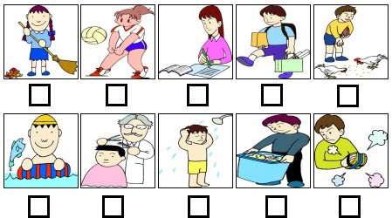
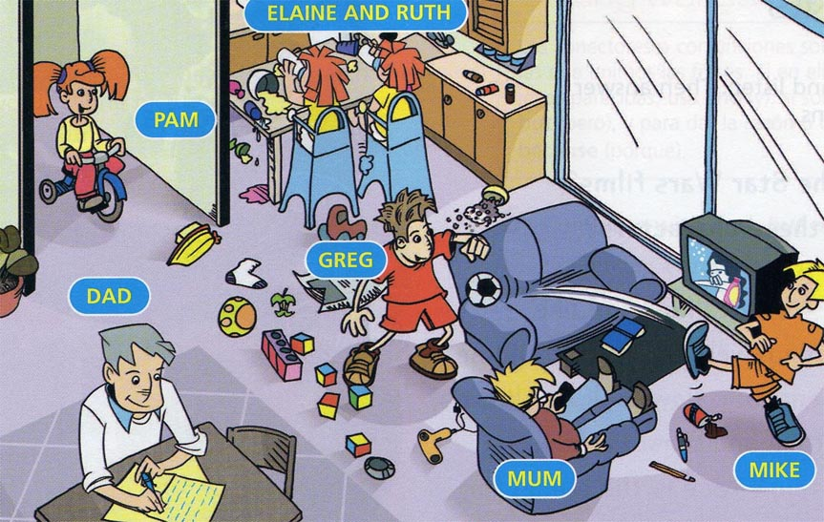

Fill in the blanks with the right preposition:

■ over  at  out
■ in  on  in front of

It is Sunday morning and the Adams are _________ home. They are ________ the living-room, which doesn´t look very tidy as the children are playing and there are toys all ____ the floor. Mum is ______________the TV. Dad is ____ his desk. Greg and Mike are playing football. The twins are________ the kitchen and little Pam is riding __________ her tricycle. They are making a lot of noise. Today they can´t go ___________because it is raining. When the sun shines they usually play ___________ the garden.

Correct the following sentences.:
- Pam is sitting in the armchair.
- Greg is doing his homework.
- Mum is listening to the radio.
- Mike is playing with Pam.
- Dad is cooking in the kitchen.
- The twins are lying on the floor.
  - Find the question to match the answer. Use the verb in brackets in the Present Continuous:
      - _______________________ (write)
A letter to his parents.
- ______________________ (watch)
Her favourite soap opera.
- _________________________ (sit)
At the kitchen table.
- ________________________ (ride)
Her tricycle.
- ______________________ (play)
With his brother Mike.

- Write questions using these prompts:
- she / watch / a film / now
- they / do / their homework
- your father / work / at the office
- your partner / ask / a question
- mum / do the ironing / at home
- the teacher / write / on the blackboard.
- the students / run / along the corridor
- your sister / talk / on her mobile phone
- they / wait / for the bus / now
- your friend / study / in his room
- the kids / walk / in the park
- the family / have lunch / at the moment
- your father / wear / a tie / today
- your friend / buy / a book / in the
- bookshop / now

Look at the pictures and fill the blanks with one of the verbs in the box in the Present Continuous, then match the sentences with the pictures.
- James ____________________ in the sea.
- Rita _________________________ her homework.
- Larry __________________________ the erasers.
- Tom ___________________ a shower after playing football.
- The barber _________________________ the boy’s hair.
- Ann _____________________ volleyball.
- Ken ______________________ the hens.
- Alan _________________________ the trashcan.
- Bob _______________________ to school.
- Linda ___________________________ the floor.
■ carry  do  feed  clean  play
■ sweep  cut go  swim  have

